To: | Cabinet
Date: | 17 September 2025
Report of: | Clive Tritton, Director of Economy, Regeneration and Sustainability
Title of Report: | Project approvals and delegations for Between Towns Road affordable housing development site (Knights Court)

Summary and recommendations
Decision being taken: | This report seeks project approval and delegations to progress the development of affordable homes at Between Towns Road (Knights Court). This includes delegated authority to enter into the land purchase, build contracts and other necessary agreements and associated development costs, and virement of HRA capital funds.
Key decision: | Yes
Cabinet Member: | Councillor Linda Smith, Cabinet Member for Housing  Councillor Ed Turner, Cabinet Member for Finance and Asset Management
Corporate Priority: | More Affordable Housing
Policy Framework: | Housing and Homelessness Strategy 2023 to 2028

Recommendation(s): That Cabinet resolves to:
- Approve the freehold acquisition of the Between Towns Road site (Knights Court) on the terms set out in this report and at Appendix 1 and 2;
- Grant project approval to finalise the scheme design, to the proposals to enter into build contracts and any other necessary agreements or contracts and incur associated development cost spends, as set out in this report, and within the allocated HRA capital budgets and business plan, for the purpose of delivering more affordable housing in Oxford;
- Delegate authority to the Director of Housing, in consultation with the Cabinet Member for Affordable Housing; the Head of Financial Services/Section 151 Officer; and the Council’s Monitoring Officer, to enter into agreements for the purchase of land; build contracts and any other necessary agreements or contracts to facilitate the development within the identified budget, for the provision of additional affordable housing; and
- Grant approval for a virement within the HRA capital budget for scheme costs of £8.9 million. The virement will be from the “Properties purchased from OCHL” (Oxford City Housing Limited) purchase line into a new scheme line to be profiled to match the build programme across the four years from 2025/26 to 2028/29;

Appendix No. | Appendix Title | Exempt from Publication
Appendix 1 | Financial Information Knights Court | This information is exempted from publication under Schedule 12A to the Local Government Act 1972 on the following basis:  Commercial Sensitivity
Appendix 2 | Planning considerations & risk | This information is exempted from publication under Schedule 12A to the Local Government Act 1972 on the following basis:  Commercial Sensitivity

Introduction and background
- The Council continues to develop a supply programme to deliver more affordable housing through multiple work streams, including the delivery of homes through the Council’s housing company – OCHL (Oxford City Housing Limited); direct delivery by the Council; joint ventures; regeneration schemes; acquisitions; and enabling activity with Registered Providers, community-led housing groups, and other partners.
- The Council seeks to deliver over 1,600 affordable tenure homes across the next four years (to March 2029), with at least 850 of those at the most affordable Social Rent level. Projections at the time of writing will deliver 1,500 homes across this period, and additional sites and developments are required to meet these targets and address housing need within the city.
- Officers continue to review opportunities to bring forward the development of further affordable homes to increase the supply available to help meet Oxford’s housing needs. This might take the form of developing more new homes; acquiring property to use as affordable housing; or switching tenures to improve affordability and access to these homes.
- This report identifies a further opportunity for the delivery of more affordable homes at Knights Court. It sits alongside two other reports (acquisition of Elsfield Hall and Cave Street into the HRA).
- These three new opportunity sites are being brought forward to collectively deliver 83 or more new units in the affordable housing programme. They have been appraised jointly and on an individual basis and meet HRA financial parameters (see ‘Financial Implications’ section). They also present an opportunity to deliver affordable housing to help meet the 1,600 homes target across the 4-year MTFP, rather than at the back end of the development pipeline programme in 2031/32.

Scheme information
- This report concerns Between Towns Road site (Knights Court) – a vacant three-storey office block on Between Towns Road, Cowley. It has a floor area of approx. 2,450sqm and is understood to have been built in the 1980s. It has a central lift/ stair core and two additional stair cores at each end of the building.
- The freeholder, West Oxfordshire District Council (WODC), initially approached OCC with the view of undertaking a joint venture but has since asked whether Oxford City Council (OCC) is interested in the freehold purchase of the building.
- The building is currently vacant and WODC has been advertising the building to let as commercial use since June 2024.
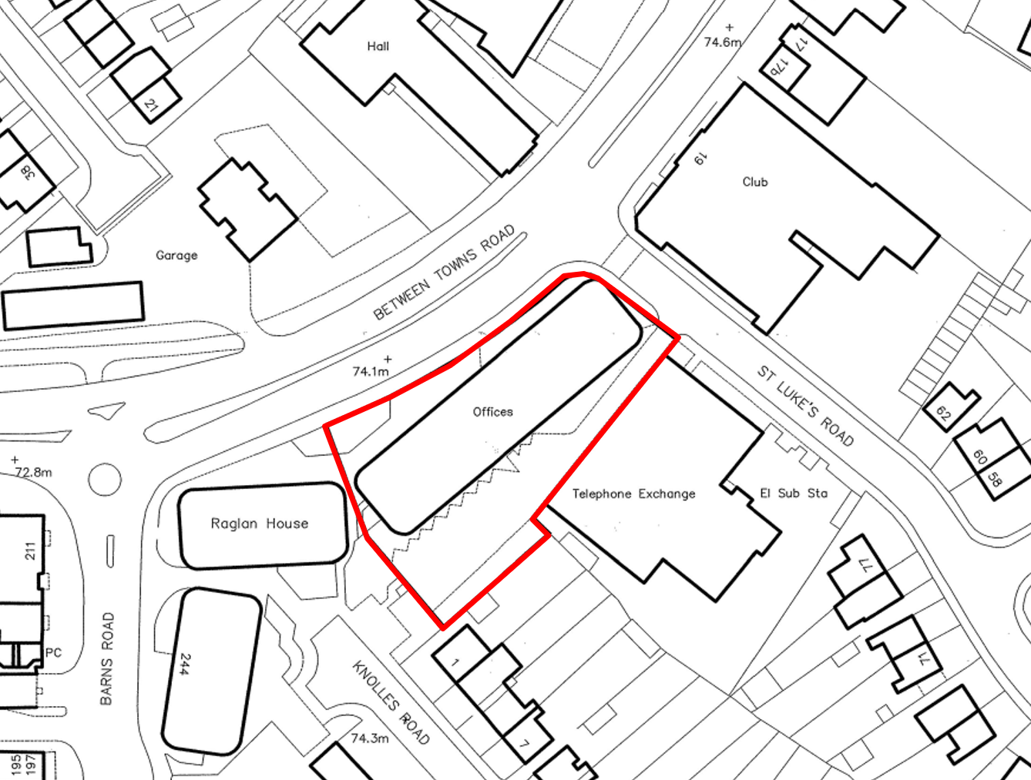
Image 1: Red line drawing of site
- The current proposal is for a 100% affordable housing development via a conversion of the existing building to residential use. The existing building is considered to have capacity for 34 homes, though this needs to be agreed through the planning process and will be subject to design development and viability considerations. The intention is to work with the existing fabric of the building and there is no proposed extension.
- The tenure mix has yet to be finalised, though initial testing includes 9 to 12 units for Temporary Accommodation, and the remaining units to be Social Rent (approximately 22 to 25). Again, the final tenure strategy will be subject to design development and viability considerations. The table below sets out an early indication of the likely mix (of property sizes and tenures) that the site is considered capable of taking in physical design terms, and in terms of ensuring the financial viability of the scheme. The viability of this tenure strategy will be dependent on the successful application to Homes England for Social and Affordable Homes Progamme for both Social Rent and Temporary Accommodation units. If grant is not available however, introduction of Affordable Rent units would provide financial viability and suitable contingency to support development costs.
Size | Social Rent | Temporary Accom | Total | %
1 bed | 22 | 9 | 31 | 91%
2 bed | 3 | 0 | 3 | 9%
3 bed | 0 | 0 | 0 | 0%
Total | 25 | 9 | 34
Percentage | 74% | 26%

- The sizes of the individual homes have also yet to be confirmed, but the Council's ambition is to prioritise 1-bed homes in order to directly respond to the housing need and the Council would be seeking a deviation from the usual planning mix to support this objective. These will always meet ‘Nationally Described Space Standards’, but in addition, the Council would seek to ensure that one bed flats are for two people. Any two bed homes should accommodate for four people; three bed homes are for five people (i.e., two double bedrooms and a single); and so forth.
- Given the nature of the building conversion, further review is needed to establish if it is possible to deliver 5% of the affordable homes to M4(3) “Wheelchair Standards (to be adapted/ adaptable for households with mobility needs). If feasible, it is expected that three homes will meet this requirement. The design and allocation of this property has yet to be completed but will be part of the planning submission.
- The proposed delivery model is for HRA direct delivery, with OCHL employed as the Development Agent through a Development Services Agreement (DSA). OCC will purchase the land from WODC. The purchase price is set out in Appendix 1. Following acquisition there will be no sale of the OCC land. Instead, OCC will grant the OCHL rights to implement the development on the Council’s land under licence. The contract between OCC and OCHL will oblige OCHL to procure the grant of this licence along with procuring and appointing a contractor.

Alternative Options Considered
- A commercial viability appraisal for the development opportunities undertaken by Savills reviewed a range of potential development strategies, including conversion of the existing building, conversion with a rooftop extension and demolition/ new build. The straight conversion strategy generated the most economically viable solution, with the building developed through permitted development rights. Increasing the build density (including the new build option) did not improve results and was identified to introduce additional spend and risk to the scheme, without presenting a significant increase in the number of units (the range going from 34 homes to 46). The option of not proceeding with Knights Court as a development opportunity would mean that the site does not realise its full potential to deliver affordable housing to help meet the 1,600 homes target across the 4-year MTFP. The current programme for Knights Court targets a project completion of end of 2027 – providing an opportunity to deliver homes relatively quickly, compared with other larger pipeline sites.
- Only ‘core’ affordable tenures have been modelled – Social Rent (as the OCC priority), Temporary Accommodation and Affordable Rent (as cross-subsidy). Initial feasibility studies show that introduction of up to nine Affordable Rent units (in a self-contained core, in lieu of Social Rent units) would provide financial viability and suitable contingency to support development costs.

Financial implications
- Introduction of this site into the development pipeline (alongside the two other new opportunity sites at Elsfield Hall and Cave Street) is contingent on re-shaping of the existing OCHL development programme to release necessary funding for the developments. This will require a virement to be approved within the HRA capital programme from the current “Properties purchased from OCHL” to the new schemes as discussed in this paper.
- The current OCHL programme review is necessary to address an existing budget pressure (attributed to delays and build cost inflation), and an adjustment is proposed to introduce additional market sale units to cover-off the budget pressure and allow for a programme contingency to be introduced. The re-shaping will then also release funding for these three new pipeline schemes. As such, the budget required for the new opportunity sites will be contained within the existing development budget envelope and will not require an increase to the existing budget.
- A separate paper will be presented to Cabinet to detail the proposed reshaping of the existing programme, as part of the initial budget reports for 2026/27 & the MTFP.
- This report seeks the required delegations to further develop the programme of affordable housing supply. The decision to proceed with any purchase or development will be supported by a development scheme appraisal/ financial modelling to ensure that the agreed financial parameters and requirements are met.
- The financial appraisal for Knights Court has established a proposed HRA capital budget for scheme costs of £8.9 million. A budget virement from the “Properties purchased from OCHL” purchase line into a new scheme line is required to match the build programme across the four years from 2025/26 to 2028/29. Further financial details are provided in confidential Appendix 1.

Legal issues
- Pursuant to section 9E(3)(c) of the Local Government Act 2000, Cabinet may delegate its functions to officers. Accordingly, Cabinet is asked to delegate authority to the Director of Housing, in consultation with the Cabinet Member for Affordable Housing, the Head of Financial Services/Section 151 Officer, and the Council’s Monitoring Officer, to enter into agreements including for the purchase of land, the DSA, license, build contracts, and any other necessary legal agreements or contracts to facilitate the purchase of the site and development of affordable housing within the identified budget and land identified in this report.
- Procurement of goods and services for the purpose of developing homes must be carried out in accordance with the Council’s Constitution, Contract Rules, procurement procedures and in compliance with the Procurement Act 2023 (or any successor legislation), including adherence to transparency, fairness and best value principles.
- The proposals set out in this report fall within Council’s statutory powers including the power to provide and manage housing through the Housing Revenue Account (HRA). The Council has the power to acquire land by agreement under section 121 of the Local Government Act 1972. The general power of competence under the Localism Act 2011 and the Local Authorities (Land) Act 1963 enables the Council to develop land it already owns. The appointment of OCHL as development agent via a DSA may rely on the teckal exemption, provided the legal criteria are met. The procurement of the DSA must still be carried out in accordance with the Procurement Act 2023, where applicable, and the Council’s Constitution.

Level of risk
- No planning permission is currently granted on the site, and further design development work is required to establish optimal planning strategy for development. Considerable due diligence has been carried out however to identify and mitigate delivery risks associated with a new development, including a building condition survey and a full planning and viability report. Consideration is still being given to whether a structural survey should be further commissioned at this stage, but as it is no longer recommended to pursue the options of adding one of two additional stories to the building, this is not considered the priority it initially was.
- Further detail on the Principle of Development has been included in Appendix 2.

Equalities impact
- There are no adverse impacts in undertaking this activity, with the potential to improve provision for persons in housing need, through the provision of more affordable and accessible housing to better meet client needs.
Carbon and Environmental Considerations
- All development schemes delivered by OCC/OCHL are subject to high sustainability standards with the expectation that they exceed statutory (building) standards.

Report author | Dave Scholes
Job title | Affordable Housing Supply Corporate Lead
Service area or department | Economy, Regeneration and Sustainability
Telephone | 01865 529123
e-mail | Dscholes@oxford.gov.uk

